**User Guide for the Zebrafish Projector GUI and Triggering Box**

**Installing the GUI**

Hardware required:

Software required:

To use this GUI, you need Matlab 2015b or 2016a. Problems arise with Matlab 2014b.

You need two monitors. The setting should be ‘expansion mode’.

The GUI will be on one monitor and the movie will be on the second monitor.

Download the Projector GUI from GitHub <https://github.com/stardust-t/ZerbrafishProject>

Put the file into a directory, such as ZebrafishGUI, on your computer. Root directory is ok.

You should have C:\FishGUI

Unzip it. Teng’s original User Guide is in the UserGuide directory.

Download and install these two first: gstreamer-1.0-x86_64-1.9.1 and Slik-Subversion-1.9.4-x64

Install Psychophysics toolbox 3 (Windows): <http://psychtoolbox.org/download/#Widows>

Unzip it.

Slik downloads psychtoolbox

A second monitor should be connected. Set the monitor to “expansion mode”. The movie will be projected onto the 2nd monitor.

To Run the GUI, open Matlab.

Go to this directory C:\FishGUI\ZerbrafishProject-master\ZerbrafishProject-master

Run the ProjectionGUI.m. The Position Parameter box will be displayed:

Click on Project to see if the installation was successful. A blue distorted bar on a black background should be projected on the second monitor.

Press Alt-tab to get to the GUI window.

**Triggering**

For Start-of-recording and Marker triggering, you need the following:

1 ) You need to install the National Instruments drivers for the IO device (NI-DAQmx).

<http://www.ni.com/download/ni-daqmx-15.5/5901/en/>

For triggering through the National Instruments IO box, the Matlab Data Acquisition Toolbox is needed. When using a NI USB-6501 for IO control, use the port 0 / line 1 as Trigger 1 (Movie Start Trigger), and port0 / line2 as Trigger 2 (spot on Trigger). Port setting and Devices setting can be changed in the GUI open function: *ProjectionGUI_OpeningFcn.*

For details, see the ***ProjectionGUI_OpeningFcn, Play_Callback*** and ***Trigger*** function.

2) A triggering box and cables. One cable goes into the computer running Matlab. The second cable goes into the Zen realtime computer. This is outlined in another document.

3) When using Zen, use Trigger 1 to **Start** **Recording** and Trigger 3 for the **Marker**.

If the trigger device is being used, a start trigger will be sent through the first channel when the movie begins, and a spot-on marker trigger would be sent through the second channel when there is a spot appearing in the movie (only at the time point when the spot first appeared).

To use it, you have to press Start Experiment in Zen. Zen will start recording once the Start Recording trigger (in the movie) is relayed to the Zen realtime computer.

**General Outline of Making a Movie**

Fill out the basic parameters in the “Position Parameter” panel (i.e. the main GUI panel).

Click “Generate Movie”

Press Cancel

A second dialog box will open. Type a movie name and Save.

This opens the spot/bar GUI.

Add spots (or bars) and click “Export”

You will be returned to the Main GUI.

Your movie will be in the MoviePool.

Click Preview to have a quick look at it (some features like play speed are incorrect).

Transfer the movie with the >>> to the playlist.

Select the appropriate values for Interval, Start Baseline and End Baseline.

Add it as many times as you want it to repeat (NB: this is in **addition** to the repeats specified in the spots/bar tab.

Click Play to play the movie on the projector.

**Set the Position Parameter page values.**

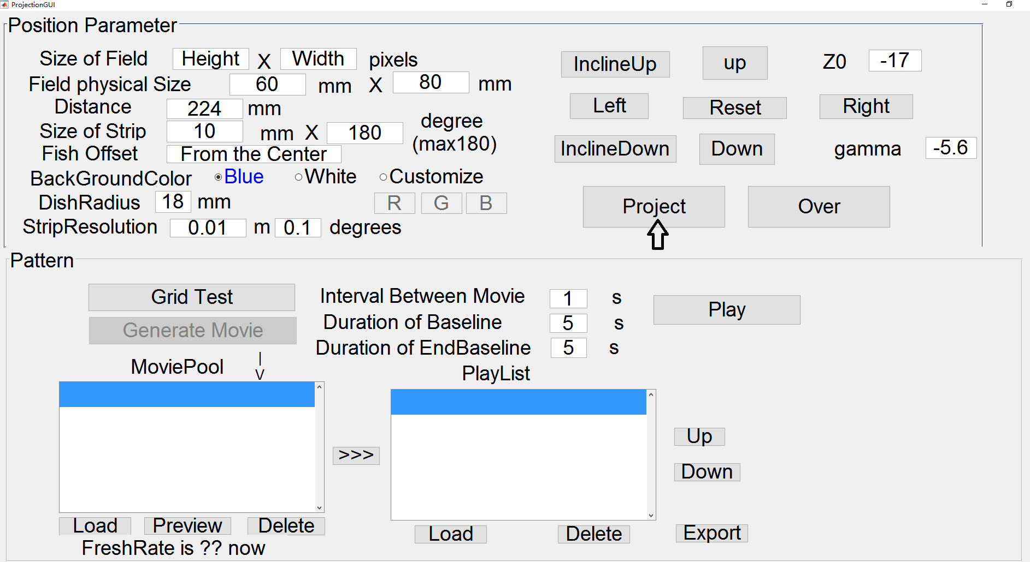

Size of Field: The resolution of the projector. This will be automatically obtained from the projector if it is not set manually. Notice! When you make moving with a screen which has a different resolution from the projector, make sure you set the Size of Field the same as projector resolution instead of using automatic settings to assure the movie you generated will be played correctly in the projector.

Field physical Size: The physical height and width of the projected image when projecting at the Distance setting. Need to be measured to give accurate project of image. Note, this is the size of the entire field of the projector.

Distance**:** Defaults to 200 mm (line 84). The distance between the center of the projector lens to the center of the image (at both height and circle). Unit in millimeter. *For projecting into a flat screen, set the Distance to a big value and set the DishRadiusto (Distance – realDistance). For example, if the real distance from the projector to the flat screen center is 150 mm, set the Distance to 10000, and set the DishRadius9850 (which is 10000 - 150). In this way, the GUI can be used to project onto a flat screen.

Size of Strip:The strip width and height you want to project. The height usually is the dish height if you want the image to cover the entire dish side. The width unit is degrees, the degrees count from the left side of the dishes (Follow the projecting direction). So the center of the strip would be 90 degrees, and corresponds to the center of the dish.

Fish Offset: Unfunctioned parameter, left for further use for correcting if the fish is not in the center of the dish.

BackGroundColor: Defaults to Blue.

DishRadius: Defaults to 18 mm

StripResolution: If your project into a field which is bigger than 1920x1280 there might be crack like the following:

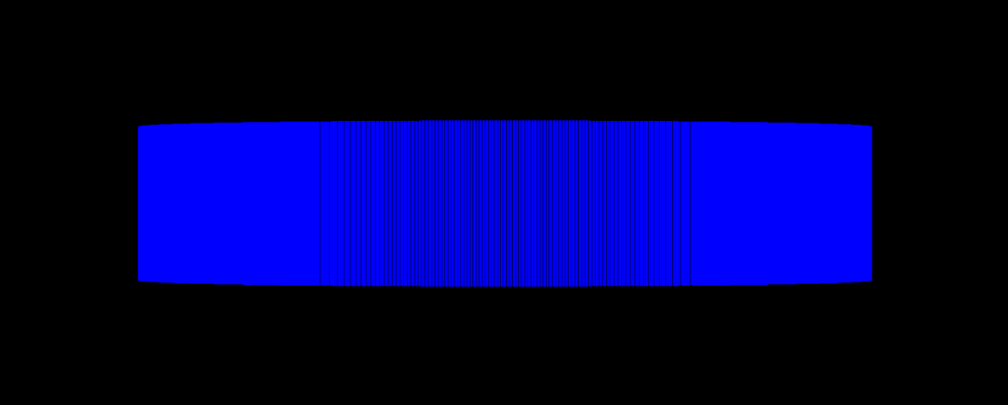

Set a high strip resolution to eliminate the crack in the middle of the strip. (Default resolution is 0.01mm * 0.1 degree, and works fine on screen resolution smaller than 1920x1280) Also, a higher resolution makes longer movie render time.

Gamma: Gamma is the angle between the projector base and horizontal, in degrees. It is used to set the incline angle of the projection direction. If the projector is level, and is projecting directly to the screen, then gamma should be made zero. Gamma is used for correcting for distortion. Line 87 (“handles.gamma=<insert gamma here>”).

InclineUp/InclineDown: This changes gamma. Incline up will increase the gamma and incline down will decrease the gamma. It is used to manually adjust the incline angle (not recommended) when the real angle can’t be obtained. It moves the projected image up or down. If you manually put in a value, press ‘Project’ to update it.

Z0: The perpendicular displacement in the Z- axis, in millimetres, of the upper edge of the dish from the projector line-of-sight. If the projector and dish are on the same level, and the dish is 10 mm high, then the projector line-of-sight is in the centre of the dish. Since the dish upper edge is 5 mm above this, then Z0=5. When the dish is lower than the projector, this value is negative. Line 87 ("handles.z0=<insert Z0 here>”). The value is measured from the top of the dish. So if you are using a 35 mm dish that is 10 mm tall, then having the projector and dish on the same surface requires a value of 5 to give a horizontally symmetrical image (there is a 5 mm offset with current dish height dimensions).

Up/Down: This changes Z0. Up will decrease the Z0 (which means the objector is going down), and Down will increase the Z0 (Projector is going up). If you manually put in a value, press ‘Project’ to update it.

Project: Start the project or refresh the image with current projecting parameters.

Over: Turn off the image projecting (does not work in Matlab 2014b).

**figure1_DeleteFcn/ProjectionGUI_OpeningFcn:** Close function and opening function of the GUI. IO trigger channels connected and disconnected function also included in these two function (If applied, see 1.3).

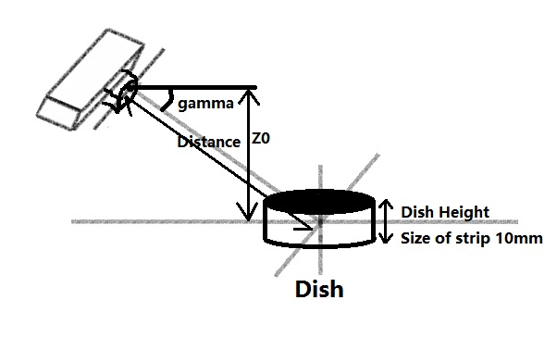

**What is the X and Y Orientation of the Projected Image**

The figure below shows three spots, 1, 2 and 3.

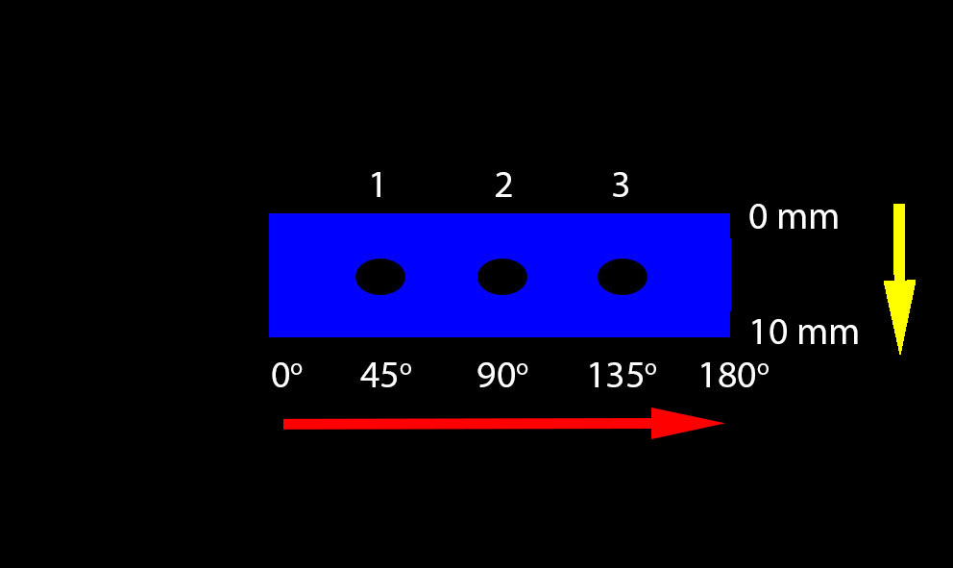

The position of a spot in x increases from 0 degrees on the left to 180 degrees on the right (red arrow).

Spot 1 has an x value of 45.

Spot 2 is in the middle and has an x value of 90. The position in y increases from 0 mm on the top to 10 mm on the bottom (yellow arrow) for a dish 10 mm tall.

**The Grid Test**

You can use this to centre the projector image on the petri dish.

The first two values indicate the number of vertical and horizontal lines (including borders).

The third value is the thickness of the lines.

Values of 3, 3, 10 will give a white centre-cross with thin lines.

***To Use***

Click on Grid Test

Put in values of 3,3,10

Click on OK

Grid Background colour is in lines 610, 611, 612 of the main GUI matlab code.

All 255 = white lines on blue background

All 0 = white lines on a black background.

**The spot panel**

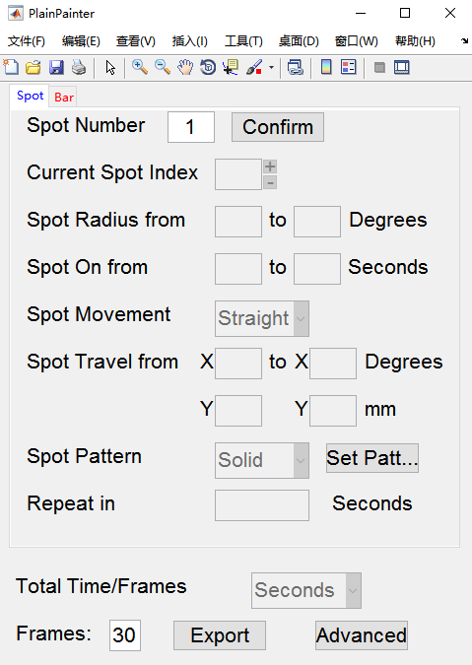

In Spot Number, type in how many spots you want and press Confirm.

In Current Spot Index, choose the spot you want to edit. Start with spot 1.

Type in the Spot Radius. For a constant size, the values should be the same.

Spot On is the value, in seconds, that the spot is present. The two values are not its duration. It is the absolute time (in seconds), measured from the start of the movie, that the spot is presented. Obviously, the difference in the two values defines the duration.

Spot Movement should be straight for simple spots. Trail allows you to produce a user defined trajectory for the spot. If you choose Trail, you will be asked, in the Matlab command line, to put in functions for the path of the spot. You will be asked to input the X(t) and Y(t), X(t) is the function which gives the X position of the spot center in time, X is unit in degrees, and count from the most left side of the strip. For example, if one want to generate a spot at the middle of the strip, but oscillate in vertical direction, the position function should be input as below: X(t) = 90, Y(t) = 5 + sin(t). !Do not let the spot go out of the boundary (you have to count the spot size), it will fail the movie generation!

Spot Travel: From (x, y) to (x’, y’)

Define how the current spot will move.

Spot Pattern can currently provide either solid or checkered spots. If you select checkered spots, you will be asked for the change rate, number of rows and columns. For example, a 100 ms change rate in a spot displayed for 1 second (with a refresh rate of 60 Hz) will mean the spot will flash ten times. A starting set of values is 100 ms, 4 rows, 4 columns.

Repeat in defines the current spot will repeat in X seconds.

For example, you want to make a spot first appeared in 1min0s, and then appeared in 1min10s, 1min15s and 1min 22s, so instead of creating 4 different spots (which you can), a more efficient way would be create a spot and set its Spot On From as 60s(1min0s) and set the Repeat in as 10,15,22 which tells the program to repeat the spot after 10, 15 and 22 seconds since the first appearance.

Total time/frames tells you how long the movie will play for. You can choose the unit, display in Frames, or in seconds.

Frames asks you to set the frame rate (frames per second) the movie will be made with. A lower number allows faster movie compilation but plays jerkily. A higher number takes longer to compile but plays the movie more smoothly. However, to avoid refresh rate inaccuracy (i.e. for accurate stimulation), you should always assign a fps which is an integer divisor of the refresh rate of the projector (which can be found on the bottom of the Main GUI). For example, if the refresh rate of the projector is 60 Hz, choose a fps for the movie which is 1,2,3,4,5,6,10,12,15,20,30 or 60.

Export will compile the movie once you have finished entering all values.

**The bar panel**

Seperate Degrees is the distance, in degrees, between bar centres.

Direction is the motion of the bar orthogonal to its long axis. For a vertical bar, direction=0 means it will drift from left to right.

Width(radius) is the bar width. Note, it is the radius, not the full width.

Speed is the speed at which the bar drifts. Speed cannot be zero (you get problems). Use 0.01 instead of zero.

Phase is XXXXXX. To produce a bar at position x (in degrees), the phase = 2(x + width). For example, to make a 10o degree wide bar appear at 90o (i.e. in the centre of the image), the phase = 2(90 +10) = 200. To make a 20o wide bar appear at 45o (hallway along the left), the phase = 2(45 + 20) = 130.

On Time is the duration in seconds that a particular bar appears for.

Export will compile the movie once you have finished entering all values.

Advanced is not functional

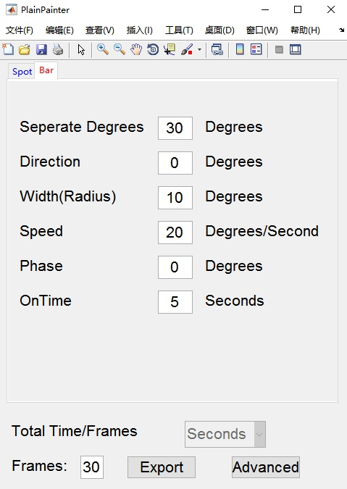

**Making the Movie (PlainPainter.m).**

After you set the project parameters, click the **Project** button. If the GUI is working successfully, you should see a blue strip projected on the second screen (or projector).

Click on **Generate Movie**. A file-open dialog box will appear asking for an undistorted movie (Plain Movie) to applied a correct distortion for project into the cylinder. To make a movie from scratch, click on **Cancel.** A second file-save dialog box will appear asking you to save the path of the Movie you are about to make (if drawn using the PlainPainter, the PlainMovie will also be saved in this directory with a prefix PlainMovie-).

Generate the movie using **PlainPainter.** There are two subpage – **Spot** and **Bar**.

Decide if you want spots or bars and then choose the appropriate panel (i.e. spot or bar panel).

Select the parameters of each spot (or bar).

If you are just testing, then select a small value for Frames. This will speed up movie compiling.

Press Export.

The main GUI will appear and your movie will be in the MoviePool.

Press Preview to have a quick look at it.

Otherwise transfer it >>> to the playlist.

Select appropriate values for interval, Baseline and Endbaseline.

Press play.

You can transfer the movie several times to repeat it. The interval is the number of seconds between the movie repeats.

Both plain movie and the projecting movie would be saved under the directory chosen by the user (see above), and the movie information will also be saved in the mat file (field *PlainMovieInfo*, and *MovieInfo*).

If you already have a movie prepared, simply load it. To load a movie, click Loadbutton below the MoviePoollistbox, and the movie can be previewed by using the Previewbutton. Click >>>button to insert the movie into PlayList**.** The same movie can be inserted into the PlayListseveral times to repeat it.

**How to Make a Hopping Bar Movie**

Currently, the Bar panel doesn’t allow you to make hopping bars. It only allows you to make drifting bars.

However it is possible to make hopping bars by making a movie of each bar position, and then incorporating them into the playlist.

Note that the GUI doesn’t allow for markers to be placed in Zen using the bars.

**Example**: Make 3 hopping bars at 45o, 90o and 135o. Each bar is 6o wide and appears for 1 second.

**Method**: Make three separate movies with a single stationary bar.

Put the three movies into the playlist.

Make three movies in the bar panel with the following values:

Separate degrees = 180 for all three bars

Direction = 0 for all three bars.

Width = 3 degrees for all three bars. Remember, width is actually the radius.

Phase = 102, 192 and 282 for the *individual* bars Remember phase = 2(position + width)

For hopping bars, speed is 0.01. Remember speed = zero causes crashes.

OnTime = 1 second.

Make movie1 with phase = 100

Make movie2 with phase = 190

Make movie3 with phase = 280.

Load the three movies into the MoviePool and then transfer the three movies into the playlist.

Select an interval between movies, Baseline and EndBaseline.

**Example 1: Make a movie with 7 hopping bars.**

Bar width is 5 degrees. Centre-to-centre distance is 20 degrees.

Bars start at -60 and go to +60.

Each bar is on for 1 seconds.

Set the bar speed to zero.

The table below shows the phase for each bar. Remember that phase = (x+width) X 2 where x is the bar angle (i.e. its position).

|  |  |  |  |  |  |
| --- | --- | --- | --- | --- | --- |
| **7 bars** | **from -60 to +60** | | **Bar Width = 5 degrees** | | |
|  |  |  |  |  |  |
| **Movie Num** | **Bar Angle** | **Phase** |  |  |  |
| 1 | 30 | 70 |  |  |  |
| 2 | 50 | 110 |  |  |  |
| 3 | 70 | 150 |  |  |  |
| 4 | 90 | 190 |  |  |  |
| 5 | 110 | 230 |  |  |  |
| 6 | 130 | 270 |  |  |  |
| 7 | 150 | 310 |  |  |  |

A trigger will be sent every time the bar appeared.